**SESSION 02 ASSIGNMENT**

**Assignment 01:** What is Boolean? Write down 3 different expression that results a Boolean type (i.e. 5 == 6)

1862//245 != 7

8*n >= 8

10%2 > 1

**Assignment 02:** What is a flow chart? Draw flow chart for the following code snippet: (you can draw on a paper, take a picture of it)

if name == “Anh Quan":

   print(“Hand some")

elif name == “Minh Duc":

   even_more_handsome = True

else:

   webbrowser.open(“<https://www.youtube.com/watch?v=04854XqcfCY>”)

Flow chart is a visualized illustration way for the if statement to help we understand the logic easier.

Draw above code flowchart:

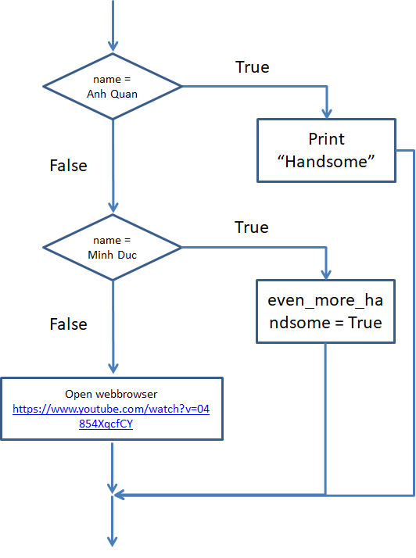

**Assignment 03:** What is nested conditionals? Write a piece of code that uses nested conditionals

Nested conditionals are when one conditional can also be nested within another.

Eg:

tich = x*y

if tich%2 == 0 and x%2 = 1:

print(“y is an even number")

else:

if tich%2 == 0 and y%2 = 1:

print(“x is an even number")

else:

print(“Either x or y is an odd number”)